Northamptonshire and Leicestershire & Rutland Track & Field Championships 2026
Rockingham Triangle Stadium
Rockingham Road
CORBY
NORTHAMPTONSHIRE
NN17 2AE

Saturday 9th & Sunday 10th May 2026
Under UK Athletics Rules
England Athletics Track & Field Licence - Number OUT25/ 262

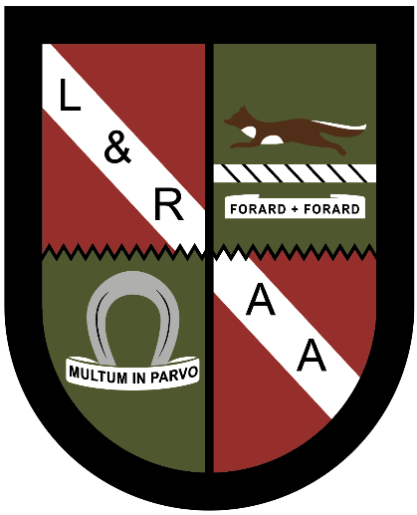

Welcome
This is my first year as President of Northamptonshire Athletics Association. I offer a warm welcome to all competitors, families and friends to our fourth consecutive Track & Field Championships in conjunction with our colleagues at Leicestershire & Rutland Athletics Association.  This is also the first year of events using the new UK Athletics age groups. In line with the recommendations from England Athletics, we are hosting a Quad Kids event for the new Under 12 age group, where each young athlete will do one sprint, one endurance run, one jump and one throw. Looking at the entries, this has clearly proved to be popular as we had to close the entries early due to lack of time on the programme. We shall perhaps be looking to extend it next year. It is important that our young athletes have the opportunity to take part in all disciplines as part of their development.  A huge amount of work goes into the planning and organisation ahead of the event, involving a small team of people. This starts in January straight after the county Cross Country Championships. A huge thank you to the planning committee and lead officials. Each year it seems to get more difficult to secure volunteers, we all have such busy lives, so we are extremely grateful to anyone who offers to help. A massive thank you to all the officials and volunteers who support the event, without whom the event would not be able to go ahead.  And a few words of thanks also for Corby Athletic Club and the club staff who host the event every year at Rockingham Triangle Stadium, a suitable stadium with facilities for county championships.  On behalf of the NAA Committee, I wish all our competitors an enjoyable weekend, should they be medal winners, competing for the first time, or achieving personal bests at their chosen event. Good luck to you all and let’s hope for the same good weather that we have had these past few years. Thank you for supporting the event.  Jim Elder  Northants AA President | On behalf of Leicestershire & Rutland Athletics Association, I would like to welcome you all to our 2026 Track & Field Championships. This is now our fourth joint championships with Northamptonshire, and we are once again very grateful to our colleagues at NAA for the invitation.  2026 is a transitional year, as we get used to the new age categories. Hopefully, the changes will have the desired effect of keeping more young athletes in the sport during the all-important exam years. Sustaining and even improving participation levels is a challenge for everyone involved in the sport and we continue to look for ways to provide stimulating competition for our young athletes.  I would like to acknowledge, with thanks, the hard work of the organising committee, our superb technical officials and volunteers. We are delighted to be providing a platform for the talented athletes from across the three counties to showcase their talents, and like you, I’m looking forward to seeing their performances.  We wish all competitors the best for a successful weekend’s athletics.  Dave Lodwick, Chair and President, Leicestershire & Rutland AA
Championships Organisation

Meeting Manager | Tricia Garner
Entries | Bryan Acford, UKA Roster System
Start lists and seeding | Jim Elder, Bryan Acford
Programme | Dave Lodwick, Tricia Garner
Athlete registration | Sue Rey, Jim Elder
Stadium Manager | Alan Wymant
Refreshments | Corby Athletic Club CIC
Gate | Alan Wymant
First Aid | Showmed Limited
Stadium Stand stewards | WDAC, Leicester Coritanian AC, Silson AC, Cadets
Announcer | Bryan Acford
Results | Fiona Lok, Alison Lodwick
Medals/Trophies/Presentation
Saturday | Special Guest: Eden Francis
 | NRAA: Terry Egan and Richard Fowler
 | L&RAA: John Heywood and June Clarke
Sunday | Special Guest: Michelle Dunkley
 | NRAA: Terry Egan and Graham Linnell
 | L&RAA: John Heywood and June Clarke

Chief Officials - Saturday

Athlete registration | Sue Rey, Ross Tyrrell
Clerk of the course | Jim Pearson
Field Referee | Adam Henley
Track Referee | James Terry
Chief Starter | Dave Lodwick
Chief Timekeeper | Laura Burton
Photo Finish | Charlie McConnell, Vanessa Powell

Officials List – Sunday

Athlete registration | Sue Rey, Annie Pointon
Results | Fiona Lok, Alison Lodwick
Field Referee | Jim Pearson
Track Referee | Lynda Plumpton
Chief Starter | Dave Lodwick
Chief Timekeeper | Liz Hinds
Photo Finish | Charlie McConnell, Vanessa Powell

Thank you to all the officials from Northamptonshire and Leicestershire & Rutland, who will be supporting the above.

A full timetable, start lists and results are available on Roster:
https://meets.rosterathletics.com/public/competitions/details/about?id=28892
 QR CODE for Results etc

Guest Presenters
Eden Francis (Saturday)
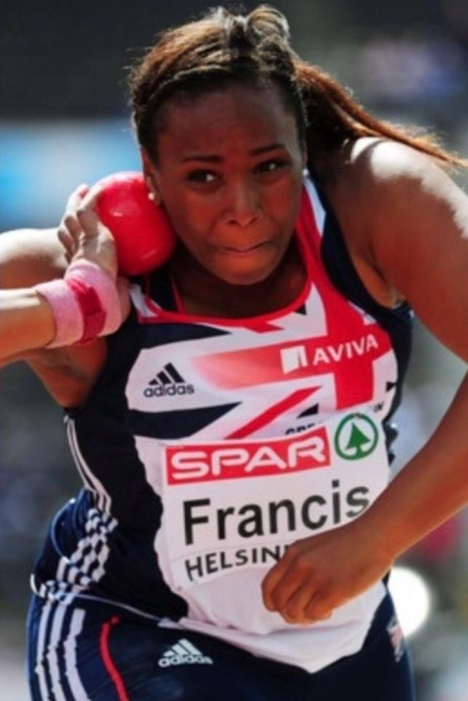
Edens first real impact in athletics, was as a shotputter. She won her first English School's medal at 13 going on to win two silver medals, followed by three golds; two at U17 and one as a Senior Girl, setting a championship record of 15.85m, which still stands today.
Eden’s first International came while still only 15 years old, representing England in the shotput. She soon found she also had a real talent for throwing the discus and in 2007 she set a British U20 record of 55.28m. As an accomplished thrower of both implements Eden was able to double up at many championships.
In 2008 Eden travelled to the European Winter Throws Championships in Croatia, setting a British first, by winning gold in the discus. She again made history, in 2009, becoming the first British athlete male or female to win discus gold at any championship at European, World or Olympic level, winning with a throw of 57.29.
Eden established herself as one of Britain's most accomplished throwers, who went on to become British champion eleven times, including shotput and the discus, achieving lifetime bests of 17.24m in the shotput and 59.78m in the discus.
Eden continues to compete for her club and work with and to inspire the next generation of athletes.

Michelle Dunkley (Sunday)
Michelle Dunkley is a former International High Jumper who started her career at Kettering Town Harriers. She went on to compete for Great Britain at the World Junior Championships in 1996 and the European Junior Championships in 1995 and 1997. Michelle set a British Junior Indoor record of 1.89 metres in 1997, which stood for 18 years. In 1998 as a Senior athlete, she competed in the European Indoor Championships and then represented England in the Commonwealth Games in Malaysia where she just missed out on a medal in fourth place. She set a personal best at an international match in France in 2000 with a leap of 1.93 metres. However, the following year achieved her lifetime best of 1.94 metres at a meeting in Loughborough. She is officially ranked eleventh on the current UK all-time list.

Timetables
Quadkids
Saturday 9th May
1300 Quadkids 75m – 7 Heats
1330 Quadkids Long Jump - U12 Boys
1330 Quadkids Howler - U12 Girls
1445 Quadkids Howler - U12 Boys
1445 Quadkids Long Jump - U12 Girls
1540 Quadkids 600m – 5 Heats
Field Events
Saturday 9th May
1100 Discus – U18 & above
1100 Long Jump - U14 Boys
1100 Shot Put - U14 & U16 Boys & Girls
1215 High Jump – All females
1215 Long Jump - U16 Boys & Above
1230 Discus - U14 - U16 Boys & Girls
1230 Shot Put - U18 & Above Men & Women
1330 Quadkids Long Jump - U12 Boys
1330 Quadkids Howler – U12 Girls
1400 Pole Vault - Men & Women
1445 Quadkids Howler - U12 Boys
1445 Quadkids Long Jump - U12 Girls

Sunday 10th May
1030 Hammer - All Age Groups
1030 Long Jump - U14 Girls
1130 High Jump – All males
1200 Long Jump - U16 and above Females
1215 Javelin - All Women
1415 Javelin – Men
1415 Triple Jump - All Age Groups

Track
Sat 9th May
1100 75m Hurdles - U14 Girls
1110 80m Hurdles - U14 Boys & U16 Girls
1120 100m Hurdles - U18 Women
1120 100m Hurdles - U16 Boys & Senior Women
1130 110m Hurdles – U18 Men
1140 200m -LRAA U14 Girls - Heat 1
1145 200m - LRAA U14 Girls - Heat 2
1150 200m -NAA U16 Girls - Heat 1
1155 200m -NAA U16 Girls - Heat 2
1200 200m - NAA U14 Girls - Heat 1
1205 200m - NAA U14 Girls - Heat 2
1210 200m - LRAA U14 Boys
1215 200m - NAA U14 Boys
1220 200m - LRAA U16 Boys
1225 200m - NAA U16 Boys
BREAK
1300 Quadkids NAA Boys 75m – Heat 1
1304 Quadkids NAA Boys 75m – Heat 2
1308 Quadkids NAA Boys 75m – Heat 3
1312 Quadkids LRAA Boys 75m
1316 Quadkids NAA Girls 75m – Heat 1
1320 Quadkids NAA Girls 75m – Heat 2
1324 Quadkids LRAA Girls 75m
1330 200m Final - LRAA U14 Girls
1334 200m Final - NAA U14 Girls
1337 200m Final – NAA U16 Girls
1340 800m - NAA U14 Girls Heat 1
1345 800m - NAA U14 Girls Heat 2
1350 800m - LRAA U14 Girls
1355 800m - NAA U14 Boys
1400 800m - LRAA U14 Boys
1405 800m - NAA U16 Girls
1410 800m - LRAA U16 Girls
1415 800m - NAA U16 Boys
1420 800m - LRAA U16 Boys
1425 800m - NAA U18 Women
1430 800m – LRAA U18 Women
1435 800m - NAA U18 Men
1440 800m - LRAA U18 Men
1445 800m - NAA & LRAA U20, Senior & Masters Women
1450 800m - NAA Senior & Masters Men
1455 800m - NAA U20 & LRAA U20, Senior & Masters Men
1500 200m - LRAA U16 Girls & U18 Women
1505 200m - NAA U18 Women
1510 200m - NAA & LRAA U18 Men
1515 200m - NAA & LRAA U20, Senior & Masters Women
1520 200m - LRAA U20 Men
1525 200m - NAA Senior Men
1530 200m - L&RAA Senior Men
1535 200m - NAA & LRAA Masters Men
1540 NAA Quadkids 600m - Heat 1 Boys
1544 NAA Quadkids 600m - Heat 2 Boys
1548 LRAA Quadkids 600m - Boys
1552 NAA Quadkids 600m - Girls
1556 LRAA Quadkids 600m - Girls
1600 5000m - Race 1 - NAA Men
1625 5000m - Race 2 - All LRAA & NAA Lady

Sunday 10th May
Time Event
1115 200mH - U14
1125 400mH - U18 and above Men & Women
1135 300m - U16 Girls
1140 300m - U16 Boys
1150 100m - NAA U14 Girls Heat 1
1155 100m - NAA U14 Girls Heat 2
1200 100m - NAA U16 Girls Heat 1
1205 100m - NAA U16 Girls Heat 2
1210 100m - NAA U16 Boys Heat 1
1215 100m - NAA U16 Boys Heat 2
1225 400m - U18 Women & Above
1230 400m - NAA U18 Men
1235 400m - LRAA U18 Men
1240 400m - NAA & LRAA U20 Men
1245 400m - LRAA Senior & Masters Men
1250 400m - NAA Senior & Masters Men
BREAK
1315 100m Final - NAA U14 Girls
1320 100m - LRAA U14 Girls
1325 100m - NAA U14 Boys
1330 100m - LRAA U14 Boys
1335 100m - LRAA U16 Boys
1340 100m Final - NAA U16 Girls
1345 100m - LRAA U16 Girls
1350 100m Final - NAA U16 Boys
1400 1500m - U14 Girls
1410 1500m - NAA U14 Boys
1420 1500m - LRAA U14 Boys
1430 1500m - U16 Girls
1440 1500m - U16 Boys
1450 100m - NAA & LRAA U18 Women
1455 100m - U18 Men
1500 100m - NAA & LRAA U20 Women
1505 100m - NAA & LRAA Senior & Masters Women
1510 100m - NAA & LRAA U20 Men
1515 100m - NAA Masters Men
1520 100m - NAA & LRAA Senior & Masters Men
1525 100m - U18 Women & Above
1535 1500m - U18 Men
1545 1500m - U20, Senior & Masters Men

